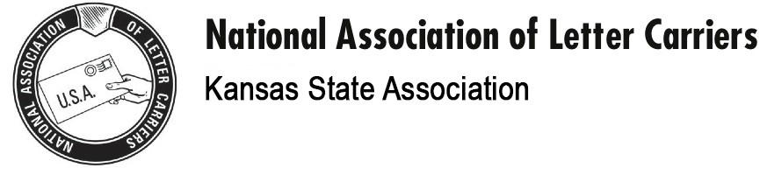

HOLUB FAMILY SCHOLARSHIP APPLICATION

Applications for the KSALC/Holub Family Scholarship must have all spaces below completed and must be postmarked by April 21, 2020. The name of the recipient will be drawn on Saturday April 25, 2020 at the KSALC Training. The scholarship award will be open to dependent children age 22 or younger. The applicant must be at least a high school senior entering an institution of higher learning or presently attending or planning to attend an accredited college or trade school. The winner will be ineligible for future scholarships. The check for the scholarship will be made out to the institution the recipient will be attending. An essay of at least 250 words on the meaning of unionism must accompany scholarship applications.

Name of Applicant:

Address:

E-mail Address:

Date of Birth:

GPA:

Name of School:

Name of KSALC Member:

Relationship of Applicant to Member:

NALC Member’s Branch:

Mail Completed Application to:

Andy Tuttle
232 Dakota St.
Lawrence, KS 66046

