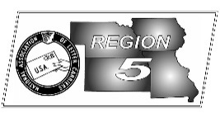
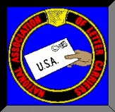
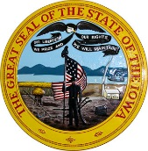
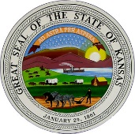
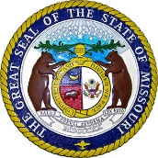
Region 5
NBA Report
Mike Birkett
September 2017 National Business Agent’s Report NALC Region 5
Contract Overwhelmingly Ratified – The active membership of the NALC has spoken. With 78,935 members voting to accept and 4,732 voting to reject, the proposed agreement has been ratified by a margin of 16 to 1. The 40 month agreement will expire on September 20, 2019. The Postal Service has been notified and as soon as information becomes available on back pay and implementation of the new contract we will get the word out. Make sure to check your NALC “APP’ and the NALC website for updates as well.

Local Memorandum of Understanding –Local negotiations will commence on October 16, 2017 and will end on November 14, 2017. It’s time for every branch to review their LMOU, consider addressing issues you have had, reach out to the active letter carriers within your local and prepare to negotiate. As in the past, we will be mailing out a guide to local negotiations to each branch with sample language. Since the service also has the right to open negotiations, branch officers should be prepared to negotiate all 22 items. The new National Agreement calls for the parties at the local level to include provisions for CCA’s to be granted annual leave. We are currently reaching out to small branches across Region 5 to ensure that every local has an LMOU. Many small branches do not have LMOU’s but do have an established past practice on how LMOU items are done in their particular office. It is our intent to help locals memorialize those practices into a new LMOU so that when the next Postmaster arrives, the wheel is not reinvented. Troy Smith from Kansas City, MO., branch 30, has stepped up and will be the Region 5 lead during this process. Branch officers with questions should call the Region 5 office at 314.985.8040.

Autonomous Vehicles - On July 27, 2017 the House Energy & Commerce committee advanced legislation on a 54 – 0 vote that begins changing regulations to allow trucks and cars to operate without drivers. Similar legislation is in the Senate. While proponents tout mobility for seniors and disabled, detractors point out the switch to automated vehicles could put up to 4 million out of work. Luckily, unions were able to successfully lobby for a 10,000 pound weight limit which will at least slow the job drain. USPS employees are well aware of the effects of automation on jobs. Tens of thousands of clerk positions no longer exist. Letter Carriers spend more time on the street than ever before. Amazon wants to flood the skies with drones. Congress needs to take a long slow look at how their actions may affect jobs and the economy before they cut down the social safety nets currently in place…if anything, they may need to expand them.

Vehicle Shelving – The old saying goes…”You just can’t make this xxxx up.” The Postal Service is testing a new process where letter carriers will load their cases/shelving directly into their vehicles. “Lifts” were installed at the test sites which carriers used to load their cases. What a great idea…we should get thousands of additional routes on this idea.

Article 12 Update – Last month I listed the offices that were under withholding. The Service has already notified us that they are cancelling some of those notices. Cancelled are: Council Bluffs, IA; Emporia, KS; Hutchinson, KS; Independence, KS; Lincoln, NE; Norfolk, NE; North Platte, NE; Omaha, NE; Wichita, KS;
Canton, MO; Gravois Mills, MO; Osage Beach, MO; Salisbury, MO; Shelbina, MO; Windsor, MO. In offices where the withholding has not been cancelled, make sure you contact the Region 5 office if any CCA’s are not converted into residual vacancies.

Penalty Exclusion – While still a while off, the Service has announced the “Penalty Overtime Exclusion” period for this year. It will begin December 2, 2017 and ends December 29, 2017.

