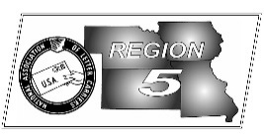
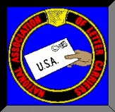
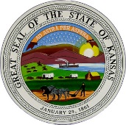
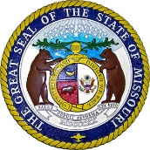
Region 5
NBA Report
Mike Birkett
October 2017 National Business Agent’s Report NALC Region 5
2018 Region 5 Rap Session – The annual Region 5 NALC Regional Rap Session will be held Saturday & Sunday, February 24 – 25, 2018. The Double Tree by Hilton in Overland Park, KS will again be the location and Shawnee Mission Branch 5521 will again host. We have reserved 160 rooms each night so make sure you make your reservations early. Rooms will be $117.00 per night plus tax for a single/double. Reservations can be made by calling 913.453.6100 under the NALC Carriers Region 5 Conference our using the 3 digit code “N2C”. Cut-off date is January 24, 2018. Reservations can be made online at:

http://doubletree.hilton.com/en/dt/groups/personalized/M/MCIMSDT-NA2-20180223/index.jhtml?WT.mc_id=POG

We once again plan an aggressive schedule with training in the main hall, multiple break-out sessions, meetings and hopefully President Rolando will once again be in attendance.

Priority Mail on Sundays – The Postal Service began testing delivery of Priority Mail on Sundays this past summer in Arizona. The test, which was apparently successful, has now expanded into Region 5 and in many cities across the country. I expect it will progress much like the Amazon roll out, only faster. While there may be a few issues as Sunday delivery expands, we must keep our eye on the prize…work and jobs. Amazon has already hired their own delivery personnel in a few cities and is using Uber and others. In a number of cities, we only deliver Amazon parcels on weekends, the rest of the week, others do it. Target recently purchased their own delivery company. Walmart is asking employees to deliver online purchases on their way home. We’re in competition for every parcel, every day.

LMOU Training – All branch presidents were notified that Troy Smith from Kansas City Branch 30 was going to do training for this office during the month of September. I hope that everyone interested was able to attend one of the sessions conducted by Troy Smith in Joplin, MO., St. Charles, MO., Columbia, MO., Lincoln, NE., Des Moines, IA., Kansas City, MO., & Topeka, KS. Thanks Troy.

Prototype Vehicles – The Service will take possession of the prototype vehicles on September 18, 2017. The “Next Generation Delivery Vehicle” (NGDV) will be tested over the course of the next 6 months. These vehicles are expected to last a minimum of 20 years; will be subjected to the everyday normal delivery routine; are to hold at least 1,500 pounds; have at least 155 cubic feet of cargo space; should be easy to repair and replacement of large body parts; remote locking and ignition. The Service is looking to substantially reduce maintenance costs over the life of the vehicle. Currently the Service has approximately 142,000 LLV’s which are well past there 24 year life expectancy.

President Trump – I’ve tried not to proffer my views on the presidential election and the Trump Presidency in this forum. Certainly some NALC members voted for this president and frankly, even though I may disagree with him on most issues, there are consequences to elections and he won. However, about a month or so ago, his statement that there were “very fine people” amongst the Alt Right, Nazi’s and Klan members in Charlottesville, VA., cannot go unchallenged. World War II cost the United States over 400,000 Americans. Those marchers in Charlottesville taint the memory and honor of those young men who gave their lives to stop fascism, tyranny and oppression. For President Trump, to not understand the difference between George Washington, Thomas Jefferson & Robert E. Lee is shameful. Yes, both Washington and Jefferson were slave owners…in a time where it was the norm and a practice none of us should look back upon with pride. However, they are both noteworthy historical figures, Presidents of the United States. Robert E. Lee broke his oath to this country and led an insurrection to secede from the United States. Lee along with Jefferson Davis are only noteworthy in history because they led an insurrection whose primary purpose was to continue slavery. That’s a “bigly” difference Mr. President.

