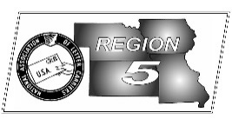
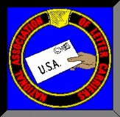
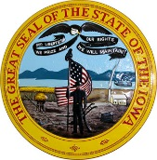
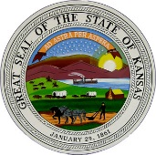
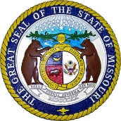
Region 5
NBA Report
Mike Birkett
January 2018 National Business Agent’s Report NALC Region 5 Region 5
Letter Carriers Political Fund – If you’ve spoken with me lately, you’ve probably noticed that I’m blue in the face. For the past year, at State Conventions, State Trainings, branch events and meetings, I’ve continuously talked about the need for letter carriers to contribute to the Letter Carrier Political Fund (LCPF). Apparently my words have either fallen on deaf ears, or those in attendance haven’t taken the message back to the workroom floor. Let’s take a look at some of the proposals that we have (temporarily) avoided just in the past year: Raise federal employees’ pension contributions by up to 6.45% of pay over the next 6 years, costing letter carriers up to $3,600 per year; Eliminating COLA’s for current and future retirees under FERS; Reducing COLAs for CSRS annuitants by .5% each year; Reducing CSRS and FERS pension benefits for new retirees by basing annuities on employees’ high five instead of high three; Eliminating the annuity supplement for FERS employees; Slashing the rate of interest paid on assets invested in the TSP Government Securities Fund (G Fund); Vaguely defined cuts of $46 billion in revenue changes to the Postal Service, most likely by scaling back door delivery and six day delivery; Moving the Postal Service from “off-budget” to “on-budget” and potentially opening the service to any across-the-board spending cuts as well as disruptions in service should the government shut down. These are just some of the proposals that can affect your job, your livelihood and your family. You have life insurance, health insurance, homeowners insurance, auto insurance and some of you even get insurance on the latest piece of technology that you purchase. It’s time for you to get some job insurance. You can contribute through payroll deduction, direct bank withdrawal and retirees can contribute through their annuities. To contribute, go to: https://www.nalc.org/government-affairs/political-activity/yes-i-want-to-become-a-pac-member and make a difference.

2018 Outlook – As I write this article in mid-December (for our branch newsletters), with the temperature dropping and while letter carriers are still buried with parcels, it’s not too early to think about the coming new year and what 2018 may bring to letter carriers and the Postal Service. Will new vehicles arrive on the scene to replace some of the safety hazards? Probably not, but perhaps a contract will be signed that begins the process. Will managers stop worshiping their false God, “DOIS”? Doubtful, they know no other way. Will mail volume fall and parcels increase? I’d like to think that letter and flat volume will stabilize, but I know parcels are going to continue to increase as customers shift their purchasing habits from brick and mortar to online shopping. One thing that I’m truly encouraged by is the new Joint Workplace Improvement Process which was negotiated last year and is in the process of being implemented. Once a location is selected, joint teams will review all factors that affect the workplace culture. Some of these factors are: treatment of employees; Communication between carriers and management; Remedies to repetitive contractual violations; Safety policies and practices both in and out of the office; Local union and management relationship; Staffing levels; and customer service, efficiency and business growth.

Volume, Competitors, Safety – As I mentioned above, this article is being written in December. Parcel volume is running about 17 – 18 percent above last year. It’s also interesting to note that our competitors can’t seem to handle the increase and are shifting their overflow to us. The USPS is expecting a fifty percent increase in drop shipments from UPS. Meanwhile, Fed-Ex is notifying their customers that they can’t guarantee delivery for parcels not in their system by December 13th. I also wanted to remind you to be vigilant about your safety and to remind everyone to use their seatbelt. I’ve been told by an Area Vice President and District Managers that they’ve seen too many carriers without seatbelts. For you own safety and to avoid discipline…buckle up!

Region 5 Field Secretary – For the past few months, this office has been searching for the best candidate we could find to fill the Field Secretary position. After an extensive search, review of over 400 resumes and dozens of interviews, I’m proud to announce that Mary Kay Decelle has been hired to fill our regional Field Secretary position. Mary is a graduate of the University of St. Thomas in Minneapolis with a degree in English and has a degree from St. Cloud State University as a Paralegal. Please give a warm welcome to Mary when you call.

