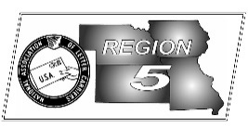
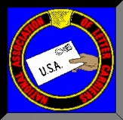
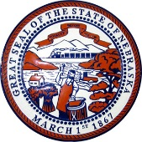
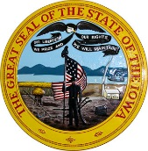
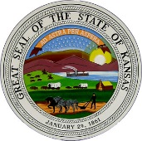
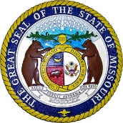
Region 5
NBA Report
Mike Birkett
December 2017 National Business Agent’s Report NALC Region 5
Merry Christmas and Happy Holidays – Stephanie, Charlie, Dave, and I would like you to know what a privilege it is to work for you and wish each and every one of you a Merry Christmas and joyous Holiday Season. Thank you all for being part of our extended family.

Speaking of the Holiday Season – Carriers are expected to deliver more than 15 billion pieces of mail this Season with about 850 million packages, a 10% increase over last year. The Service expects December 18th will be its busiest day online, so expect a late rush of packages this year as our customers continue to increase their online shopping and expect near immediate delivery. Meanwhile, letter and flat volume continues to fall. This makes it especially important that we do our best when delivering parcels to our customers. There is a lot of competition for that parcel we deliver and more in the future. USPS has the best last mile of delivery in the world, because of you, and we need to capitalize on your experience, professionalism and dedication.

Dignity and Respect – It goes without saying that we demand that letter carriers must be treated with dignity and respect by management. What we occasionally forget because of pressures of work, issues at home and life in general, is to make sure we treat each other with the same dignity and respect we demand from others. I remember being taught that we should treat others the way that we wish to be treated. This goes for all managers, branch officers, members or non-members. Perhaps this is the perfect time of year to reflect and change the way we deal with our co-workers in the upcoming New Year.

Autonomous Delivery Vehicles - In my September article I wrote about autonomous vehicles and my concern about legislation that may affect jobs across this country. Recent news articles in “Air Cargo World” & “Freight Waves” have reported that the USPS, working with the University of Michigan, is exploring the use of autonomous technologies and could deploy a prototype vehicle by this December. From there, the Service is expected to search for a company to build the “ARDV’s” (Autonomous Rural Deliver Vehicle) with plans to test them on up to 10 routes in 2019. If these tests are successful, the service expects to deploy the vehicles on 28,000 rural routes by 2025. Apparently the USPS has outlined five potential uses: 1) Driving the letter carrier for curbside delivery which would allow the carrier to sort mail between deliveries. 2) Driverless parking where the vehicle will park itself while the carrier gets out and begins deliveries. 3) Following the letter carrier, reducing “dead heading” and certain dismounts. 4) The vehicle could return to the office to pick up additional or late arrival mail while the carrier continues working. 5) As a mobile parcel locker where the vehicle can be dispatched to a customer when convenient, allowing 24/7, on demand delivery. While these articles do not directly mention city letter carriers, it’s inconceivable that the Service would not use these vehicles in our craft.

Safety – At a recent trip to NALC Headquarters in Washington, D.C., I took time to stop at the memorial for letter carriers who have died on duty. It’s sad that a workforce has so many who have died that a memorial wall can be created. Perhaps during this season you can take a minute and say a short prayer for those who have passed while delivering the mail and as important, make sure your name is never placed on the wall. Take the time that’s needed to work safely; the time to make sure your vehicle and surrounding work area are safe; the time to turn off your vehicle and park it properly so it doesn’t roll away; the time to look behind your vehicle when you have to back; the time to cool down in the summer when overheating and the time to warm up in the winter when freezing. Most important, take the time you need to be safe and go home every day.

Tidbits - Since late in 2013, over 25,000 City Carrier Assistants have been converted to career status.

