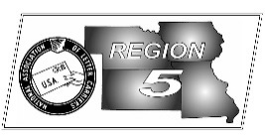
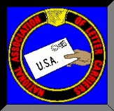
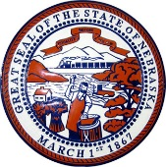
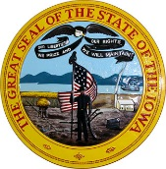
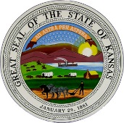
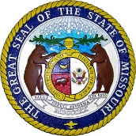
Region 5
NBA Report
Mike Birkett
August 2017 National Business Agent’s Report NALC Region 5 Region 5
Article 12 Withholding – This office has received numerous Withholding Notices from the USPS over the past month. Those offices, offices within 50 miles and the number of employees affected are: Davenport, IA – 1 Clerk; Des Moines, IA NDC – 10 Clerks, Des Moines, IA – 6 Mail Handlers; Des Moines, IA P&DC – 36 Clerks;
Emporia, KS – 1 Clerk; Hutchinson, KS – 1 Clerk; Independence, KS – 1 Clerk; Iowa City, IA – 2 Clerks; Kansas City, KS – 1 Clerk; Lincoln, NE – 1 Clerk; Moline, IL – 1 Clerk; Mt. Pleasant, IA – 2 Clerks; Norfolk, NE – 1 Clerk; North Platte, NE – 5 Clerks; Omaha, NE – 2 Clerks; Shawnee, KS – 5 Clerks; Sioux City, IA – 4 Clerks; Springfield, MO – 7 Clerks; St. Joseph, MO – 1 Clerk; Topeka, KS – 5 Clerks; Waukon, IA – 1 City Carrier; Wichita, KS – 1 Clerk. Branch presidents have been contacted and requests for information submitted to the Service. I’m hopeful that most of these Withholdings will be cancelled. In fact, the one for Council Bluffs, IA already has. Grievances will be filed if the Service fails to meet their contractual responsibilities. This office has already requested information from Western Area and local entities as well. We will do everything we can to limit any negative effects on the letter carrier craft and CCA’s.

Amazon - Customer, not a friend. While Amazon is taking over the world, one piece of the economy at a time, it’s vital that we recognize that although Amazon has certainly been a boon to the finances of the USPS, they are using us to their benefit, not for some altruistic cause. They ship through us because we’re cheaper and have the best last mile delivery network, period. If and when they can find an alternative method, they will be gone. Already they have their own drivers (like Uber), who are delivering parcels in some of the larger markets around the country. Amazon is one of the largest investors in drones and even designed “hives” from which their drones can leave from and return to. They are also anti–union. The following was taken from http://leftlaborreporter.com: “In November 2000, 50 workers at an Amazon call center in Seattle began efforts to organize a union. In January 2001, Amazon announced that it was closing its Seattle call center. The company closely monitors its employees every move. In Amazon’s cavernous warehouses, workers are constantly pressured to keep on the move in order to meet production goals. In 2011 when conditions at an Amazon warehouse near Allentown, Pennsylvania got oppressive because of the summer heat, the company showed little interest the workers’ safety. When temperatures inside the warehouse reached more than 100 degrees, workers requested that the warehouse’s doors be left open to help cool them off. Amazon managers refused. Workers started coming down with heat related illnesses. A local doctor who treated some of the workers at an emergency room contacted the US Occupational Safety and Health Administration to report an “unsafe environment” at the warehouse. Instead of taking steps to make the warehouse safer, Amazon stationed ambulances and paramedics in the parking lot to treat people overcome by the heat.” Amazon is trying to surpass Walmart as the nation’s number one retailer…at any cost.

WIMP – Where Is My Package – We all know the importance of delivering parcels accurately and on time. Customers are tracking our scans and cameras are everywhere. WIMP is a new voluntary service project which was started to address the high rate of customer complaints concerning package delivery. The project began in Baltimore, Maryland and has crept out from there. Local NALC branch presidents will be asked if they want to participate in the project (voluntary) and if so, the program will be explained and training given. A part of the project acknowledges that no discipline will be administered for miss deliveries, which the NALC, thru this office, will monitor to insure the agreement is kept.

Grocery Deliveries – I’ve reported in the past that the USPS was testing grocery deliveries in a few areas around the country. The latest news is that letter carriers are making 35,000 grocery deliveries per day. Coming soon to your area?

Food Drive – Final totals are in for Region 5. We collected a total of 3,159,155 lbs. and over $75,000.
Kansas: 534,991 -8%; Nebraska: 586,590 +17%; Missouri: 1,360,600 -15%; Iowa: 676,974 +33%

